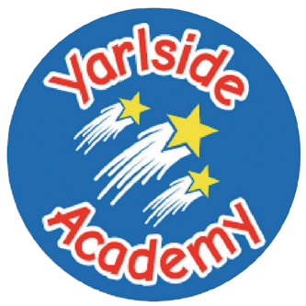
Academy
Filled Tondo Panini
(cheese, ham and cheese or cheese and pepperoni)
served with nachos, sweetcorn and salad
or Jacket potato served with beans/cheese/tuna
Dessert
Cheese, biscuits and apple

Fish and Chips
Breaded cod or Salmon goujons served with chips, beans and gravy
or Jacket potato served with beans/cheese/tuna
Dessert
Lemon drizzle cake

Week Victoria
1

Monday
Wednesday
Friday
Tuesday
Thursday

A basket of fruit, yogurt and water alongside a selection of white and wholemeal bread will be available daily.

We also have a daily Deli Bar and Jacket Potatoes are also available daily with a variety of fillings.

Allergen information available upon request.

Roast Chicken
served with roast and mash potatoes, yorkshire pudding and farmhouse vegetables
or Jacket potato served with beans/cheese/tuna
Dessert
Jelly and fruit

Chicken Burger
served in a bun with lettuce, tomato and mayonnaise and coleslaw, sweetcorn and nachos
or Jacket potato served with beans/cheese/tuna
Dessert
School cake and custard

Meatballs
served in gravy with pasta and diced carrots and peas
or Jacket potato served with beans/cheese/tuna

Dessert
Ice-cream and fruit

