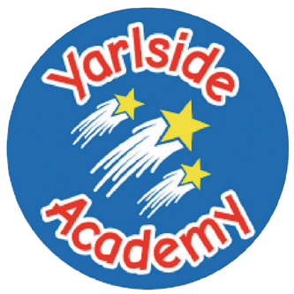
Academy
Toad in the hole
Served with mash potato, Yorkshire pudding,carrot batons, peas and gravy
or Jacket Potato served with beans/cheese/tuna
Dessert
Chocolate muffin

Sausage roll
Served with beans

or Jacket Potato served with beans/cheese/tuna
Dessert
Jam and coconut sponge and custard

Pasta Bolognaise
served with garlic bread and sweetcorn
or Jacket Potato served with beans/cheese/tuna
Dessert
Cookies

Chicken flatbread
(with garlic/herb or fajita seasoning)
Served with salad, coleslaw and sweetcorn
or Jacket Potato served with beans/cheese/tuna
Dessert
Chocolate brownie

Chicken korma
Served with rice, peas, naan bread and poppadoms
or Jacket Potato served with beans/cheese/tuna
Dessert
Iced Grasmere ginger biscuits


A basket of fruit, yogurt and water alongside a selection of white and wholemeal bread will be available daily.

We also have a daily Deli Bar and Jacket Potatoes are also available daily with a variety of fillings.

Allergen information available upon request.

Week Victoria
2

Monday

Wednesday
Friday

Tuesday
Thursday

