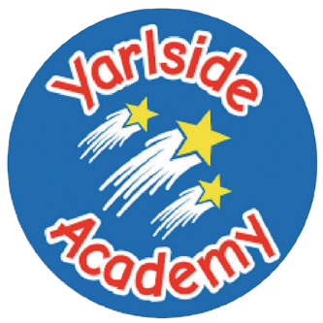
Academy
Meat and Potato pie
Served with peas and gravy

or Jacket Potato served with beans/cheese/tuna

Dessert
Carrot cake
Southern fried chicken goujons
Served with sliced potatoes and broccoli
or Jacket Potato served with beans/cheese/tuna

Dessert
Ice-cream and fruit


A basket of fruit, yogurt and water alongside a selection of white and wholemeal bread will be available daily.

We also have a daily Deli Bar and Jacket Potatoes are also available daily with a variety of fillings.

Allergen information available upon request.

Week Victoria
3

Monday

Wednesday
Friday

Tuesday
Thursday
Fish finger wrap
Served with chips, lettuce and cucumber
or Jacket Potato served with beans/cheese/tuna

Dessert
Gingerbread and custard

Chicken fried rice
Served with Chinese curry, noodles and prawn crackers

or Jacket Potato served with beans/cheese/tuna

Dessert
Lemon iced sponge

Individual Pizza slice (pepperoni or cheese and tomato)
Served with mixed salad, sweetcorn and coleslaw
or Jacket Potato served with beans/cheese/tuna

Dessert
Shortbread

